
Ikhamanga Building, Government Boulevardi Riverside Park, Mpumaianga Province
Private Bag X 11341 , Mbombela, 1200.
Tef.• 013 766 5552/5115, Toll Free Line: 0800 203 116
Litiko le Temfundvo, Umnyango we Fundo Departement van Onderoys Ndzawuk•» ya Dyondzo
QUARTERLY RETURNS FOR SUBSIDY IN RESPECT OF DAY CARE CENTRE (CRECHE)

SUBSIDY CLAIM FOR THE: Fourth/ 4th QUARTER: 2026

NAME OF DAY CARE CENTRE: BETHEL CRECHE & PRE-SCHOOL

SECTION A

POSTAL ADDRESS RESIDENTIAL ADDRESS
Box: 1698 Street: STAND NO.: 1122 SANDRIVER
Town: HAZYVIEW Town: HAZYVIEW
Code: 1242 Code: 1242
Tel no: 066 238 2295 Fax no: N/A
Contact Person: NDLOVU SS Cell no: 066 238 2295
Bank Name: FNB Town: HAZYVIEW
Account number: 62499349639 Branch Code: 271-152

SECTION B
NUMBER OF CHILDREN ATTENDED DURING THE QUARTER AS PER ATTENDANCE REGISTER.
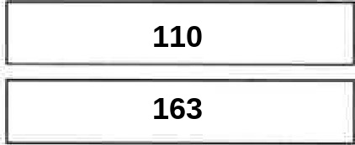
NUMBER OF CHILDREN
NUMBER Of ATTENDANCE'S

AMOUNT OF SUBSIDY

I declare that the above information is correct and a true reflection of the financial position

SECTION C
CHAIRMAN | DATE
TREASURER | DATE
MANAGER DATE


MPUMALANGA
THE PLACE OF THE RISING SUN

INCOME/EXPENDITURE FOR THE: Fourth/ 4th QUARTER: 2026
NAME OF DAY CARE CENTRE: BETHEL CRECHE & PRE-SCHOOL

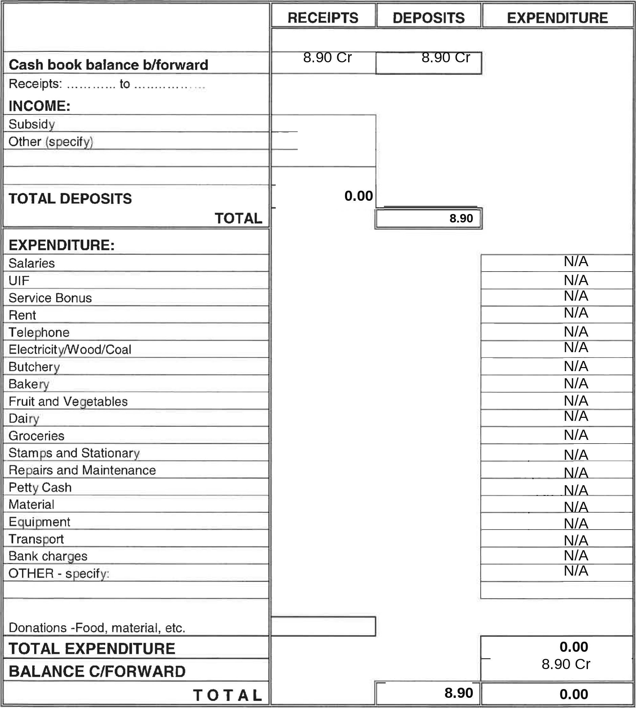`
I declare that the above information is correct and a true reflection of the financial position of the project

A COPY OF THE COMMITTEE'S MINUTES DATED202 AND BANKSTATEMENT ARE ATTACHED
MANAGER: ____________________ CHAIRMAN: ________________TREASURER:________________
DATE:___________________ DATE:__________________ DATE:____________________

PETTY CASH EXPENDITURE FOR THE: Fourth/ 4th QUARTER 2026
NAME OF DAY CARE CENTRE: BETHEL CRECHE & PRE-SCHOOL
(Petty cash book expenditure must be a true reflection of petty cash entries)
1. Petty cash balance b/fwd: 
2. Petty cash supplementary withdrawal:
DATE | REFERENCE NO |  | AMOUNT
 | TOTAL
3. Expenditures:
Stationary |  |  |  | N/A
Trans ort |  |  |  | N/A
Stamps |  |  |  | N/A
Milk |  |  |  | N/A
Bread |  |  |  | N/A
Cleaning materials |  |  |  | N/A
Fruit and Vegetables |  |  |  | N/A
 |  |  |  | N/A
Other (specify) |  |  |  | N/A
 |  |  |  | N/A
 |  |  |  | N/A
 |  |  |  | N/A
 |  |  |  | N/A
TOTAL PETTY CASH EXPENDITURE  PETTY CASH BALANCE C/F-WD |  |  |  | N/A
 |  |  |  | N/A
 |  |  |  | N/A
TOTAL |  |  |  | N/A
I declare that the above information is correct and a true reflection of the financial position of the project
MANAGER: ______________________________ DATE: _________________

CHAIRMAN: _____________________________ DATE: _________________

TREASURER: ____________________________ DATE: _________________

BANK RECONCILIATION STATEMENT FOR THE Fourth/ 4th QUARTER 2026
NAME OF DAY CARE CENTRE: BETHEL CRECHE & PRE-SCHOOL

BALANCE B/FWD |  | R 8.90 Cr
+ INCOME |  | R 0.00
 |  | R 8.90
+ INTEREST RECEIVED |  | R 0.00
 |  | R 8.90
- EXPENDITURE |  | R 0.00
 |  | R 8.90
- BANK CHARGES |  | R 0.00
= CASH BOOK BALANCE |  | R 8.90 Cr
 |  | R
+ OUTSTANDING CHEQUES: |  | R
Cheque no | Amount | R
Cheque no | Amount | R
Cheque no | Amount | R
Cheque no | Amount | R
Cheque no | Amount | R
Cheque no | Amount | R
Cheque no | Amount | R
Cheque no | Amount | R
 |  | R
= BANK STATEMENT BALANCE |  | R 8.90 Cr
I declare that the above information is correct and a true reflection of the financial position of the financial position
MANAGER: ______________________________ DATE: _________________

CHAIRMAN: _____________________________ DATE: _________________

TREASURER: ____________________________ DATE: _________________

